**﻿AGGLOMERATIVE CLUSTERING**

**Business Problem** = ﻿ ﻿﻿﻿ ﻿ ﻿Obtain optimum number of clusters for the airlines data.

* **Name of the File: -** EastWestAirlines.xlsx
* **Size of the File: -** 270 KB
* **Data: -** 4000 Observation, 11 Variable
* **Missing Value: -** Data don’t have Missing Values

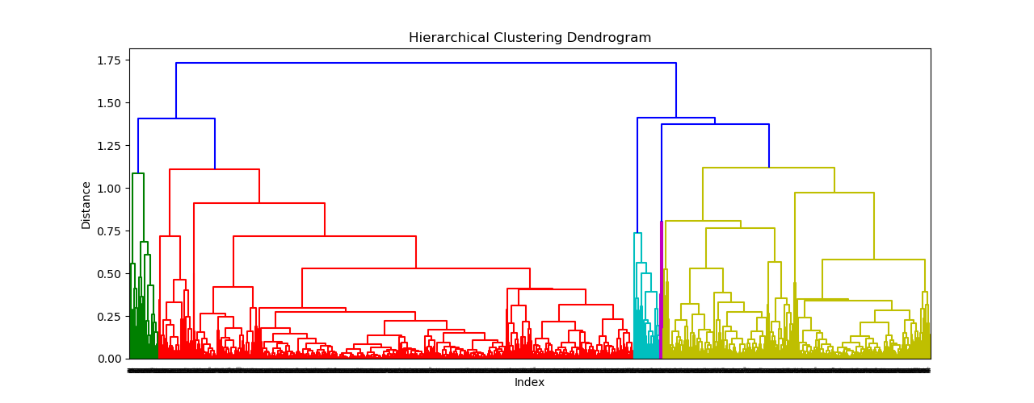**Dendrogram = ﻿**

**Inferences = ﻿** In the East-West Airlines data set, there are a total of 4000 flight records which we can differentiate into five main groups based on balance as shown in the above dendrogram. Cluster 0 has the highest balance among all and balance decreases continually in cluster 1,2,3 in this way cluster 4 has the least balance. We can see that all records in cluster 0,2,4 are win awards while the record in clusters 1 and 3 do not win. So in that way, we can classified airline records.

**Python code file**: - [Airlines Analysis.py](https://github.com/nilaydeshmukh0/Agglomerative-Clustering/blob/master/Airlines%20Analysis/Airlines%20Analysis.py)